**Drawing Shape**

**Version 1.0**

**Version History**

|  |  |  |  |
| --- | --- | --- | --- |
| **Version** | **Date** | **Handled by** | **Comments** |
| V1.0 | 16-Aug-2019 | ZL Chen | First version release. |

Precondition Setting:

Please make sure the DUT is connected to the internet.

* Install the Python 3.6.8.
  + Please refer to the “Python 3.6.8 installation.pdf” attachment.

(\automation\sop\other\Python 3.6.8 installation.pdf)

* Install the third party library.
  + Double click the “Envir_Install.exe” under the installer folder.

(\automation\installer\Envir_Install.exe)

Please follow the implement as below:

N/A

Step 1:

Please copy the luminance_pattern folder of the suite to the device’s desktop.

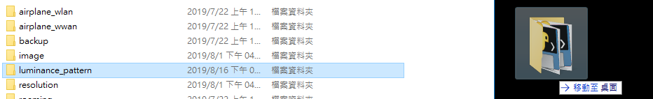

Implement the drawing_shape.exe under the “\ luminance_pattern \” folder. (Figure 2)

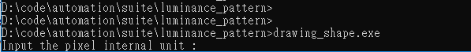

Step 2:

Please input the “pixel internal unit” you want. (Ex: 2) and number of square. (Ex: 10), and then tap the “Enter”.

The program is start running.

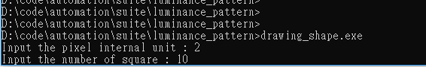

Step 3:

The result as below:

